**List of Publications on Maize Diseases using Machine Learning**

These papers addresses the challenges of accurately identifying corn diseases from leaf images, which is essential for effective disease management in agricultural practices. The study proposes different uses of different models (deep transfer learning, convolution neural network) on the corn disease dataset.

* Classification of Corn Diseases from Leaf Images Using Deep Transfer Learning
  + Dataset
    - Gray leaf spot
    - Common rust
    - Northern leaf blight
* Maize Leaf Disease Classification Using Convolutional Neural Network
  + Dataset
    - Gray leaf spot
    - Common rust
    - Northern leaf blight
* Convolutional neural network for maize leaf disease image classification
  + Dataset
    - Cercospora
    - Common rust
    - Northern leaf blight
* Deep Learning-Based Identification of Maize Leaf Diseases Is Improved by an Attention Mechanism: Self-Attention
  + Dataset
    - Southern corn leaf blight
    - Gray leaf spot
    - Southern corn rust

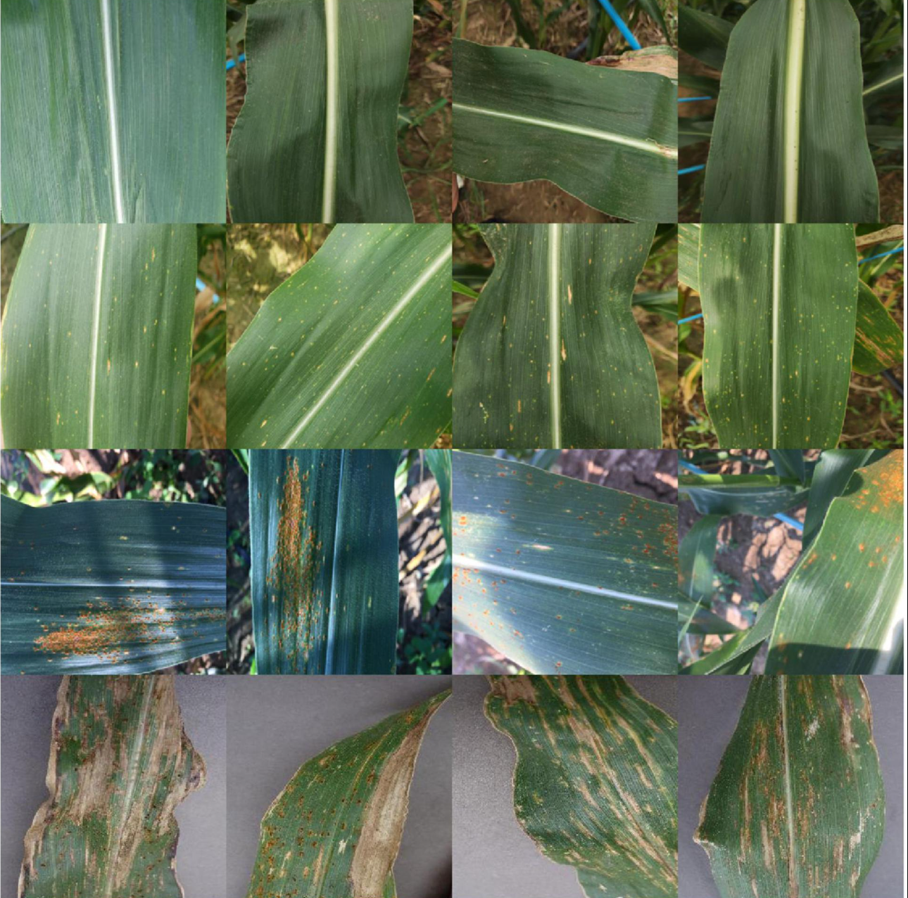

B

A

**(A)** = Healthy (**B)** = Southern corn leaf blight



D

c

**(C)** = Southern corn rust (**D)** = Gray leaf spot

A new Dataset have been provided by Lacuna which target the diagnostics of Maize Lethal Necrosis (MLN) and Maize Streak Virus (MSV) diseases.

